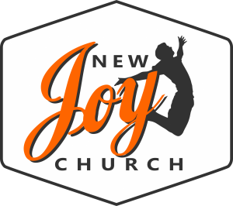
New Joy BIC Church
35 New Joy Drive
Ephrata, PA 17522
(717) 733-2864 - Office

New Joy Volunteer Affidavit

Name: ___________________________________________________________________ Last First Middle Initial

Section I — PA Residency

I affirm that I have NOT lived outside the state of Pennsylvania during the last 10 years.

Section II - Personal Data

Current Address:
Street: _____________________________________
City: _______________________________________
State: ______________________________________
Zip: ________________________________________
Email: ______________________________________ Phone #: __________________ Date of Birth: _______________________ Gender: ___________

Section III — New Joy Safety Procedure (Check the box if you agree)

I understand that the safety of our children and students is a priority at New Joy. Any
investigation involving child abuse in which a New Joy volunteer might be named a
perpetrator, will result in the volunteer being moved into a non-serving status pending
completion of the county’s investigation.

The information I have given in this document is correct and complete to the best of my
knowledge. I have agreed that false information or significant omissions may disqualify me
from further consideration for service and may be considered justification for dismissal if
discovered at a later date.

Signature __________________________________________________ Date _________

9.30.19

